**PRACTICAL 8**

**NAME: SHREYA SANJAY CHAUDHARI**

**ROLL NO: 04 BATCH: A DIV: COMPS 3**

**Aim:**  To implement Fractal (Koch Curve).

**Objective:**

A Koch curve is a fractal curve that can be constructed by taking a straight-line segment and replacing it with a pattern of multiple line segments. Then the line segments in that pattern are replaced by the same pattern.

**Theory**:

1) Draw an equilateral triangle.

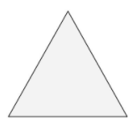

2) Divide each side in three equal parts.

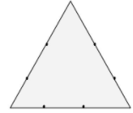

3) Draw an equilateral triangle on each middle part. Measure the length of the middle third to know the length of the sides of these new triangles.

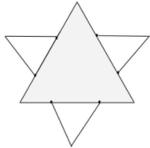

4) Divide each outer side into thirds. You can see the 2nd generation of triangles covers a bit of the first. These three line-segments shouldn’t be parted in three.

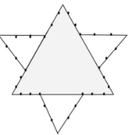

5) Draw an equilateral triangle on each middle part.

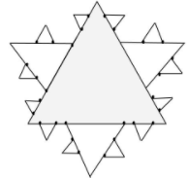

**Program: #include<graphics.h>**

**#include<conio.h>**

**#include<math.h>**

**void koch(int x1, int y1, int x2, int y2, int it)**

**{**

**float angle = 60*M_PI/180;**

**int x3 = (2*x1+x2)/3;**

**int y3 = (2*y1+y2)/3;**

**int x4 = (x1+2*x2)/3;**

**int y4 = (y1+2*y2)/3;**

**int x = x3 + (x4-x3)*cos(angle)+(y4-y3)*sin(angle);**

**int y = y3 - (x4-x3)*sin(angle)+(y4-y3)*cos(angle);**

**if(it > 0)**

**{**

**koch(x1, y1, x3, y3, it-1);**

**koch(x3, y3, x, y, it-1);**

**koch(x, y, x4, y4, it-1);**

**koch(x4, y4, x2, y2, it-1);**

**}**

**else**

**{**

**line(x1, y1, x3, y3);**

**line(x3, y3, x, y);**

**line(x, y, x4, y4);**

**line(x4, y4, x2, y2);**

**}**

**}**

**int main()**

**{**

**int gd = DETECT, gm,i,n, x1 = 100, y1 = 100, x2 = 400, y2 = 400;**

**initgraph(&gd,&gm,"..//bgi");**

**printf("Enter number of interations");**

**scanf("%d",&n);**

**for(i=0;i<n;i++)**

**{**

**cleardevice();**

**koch(x1, y1, x2, y2, i);**

**getch();**

**}**

**return 0;**

**}**

**Output:**

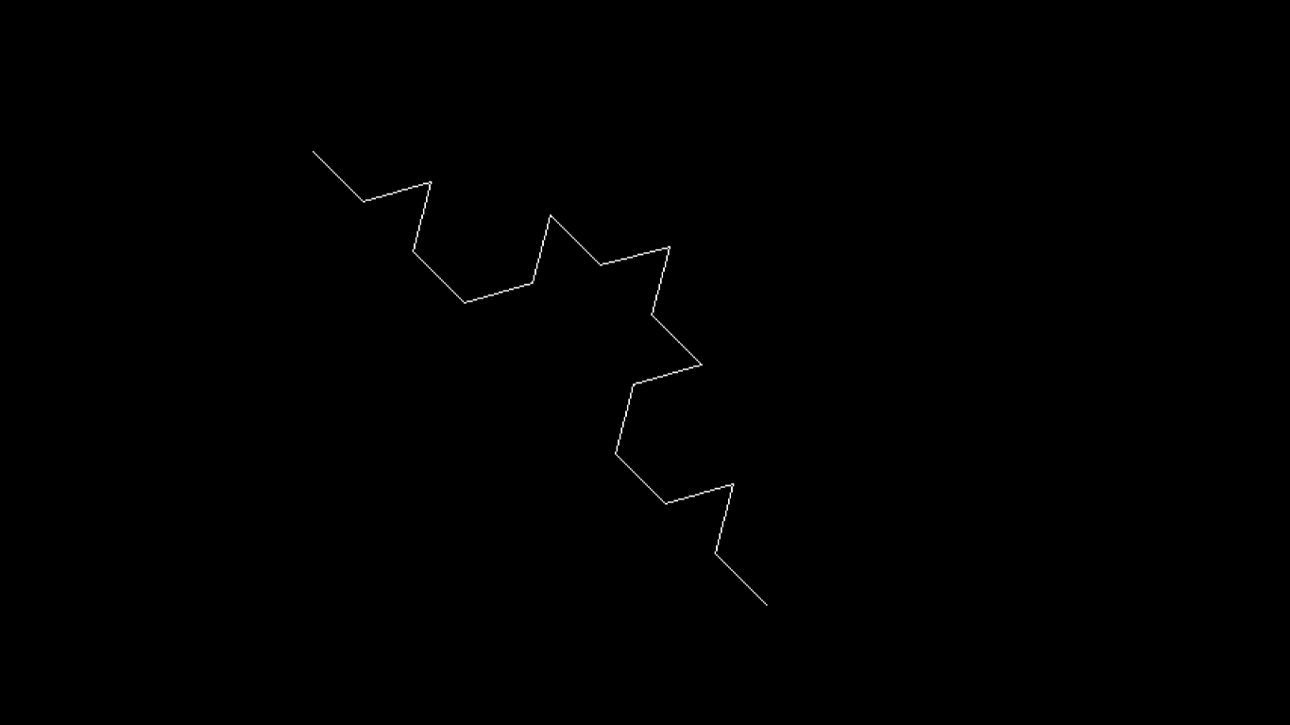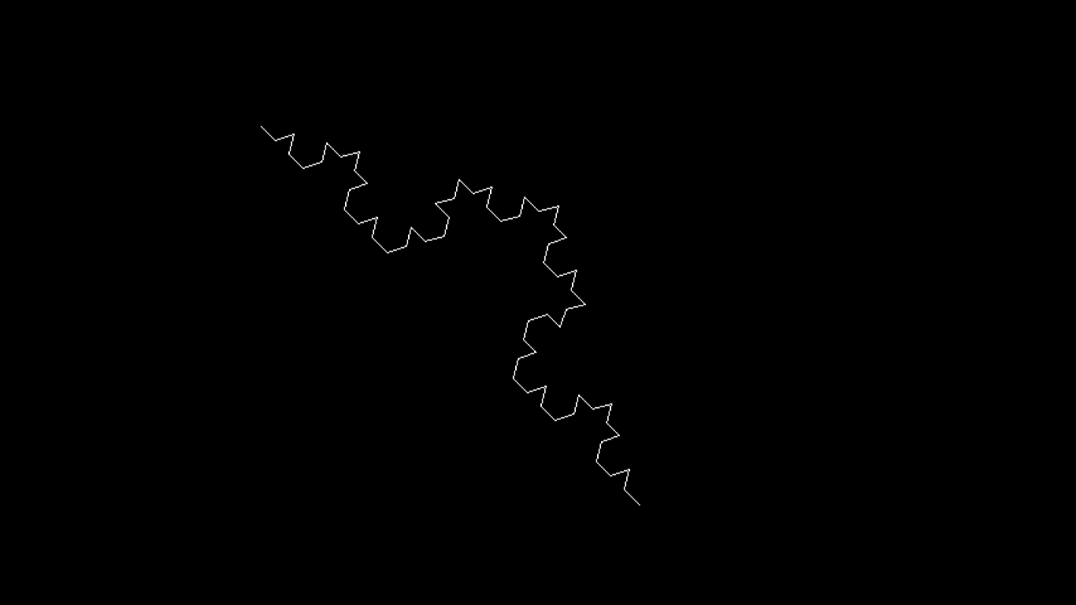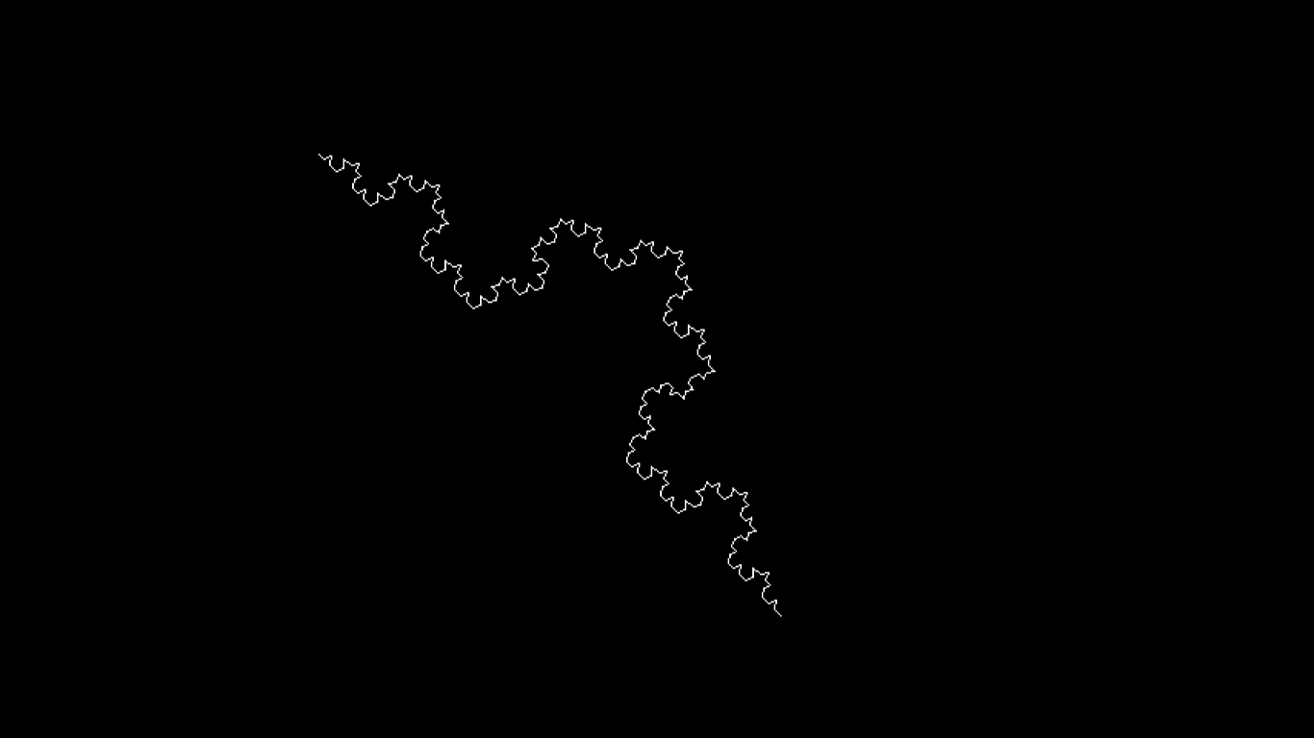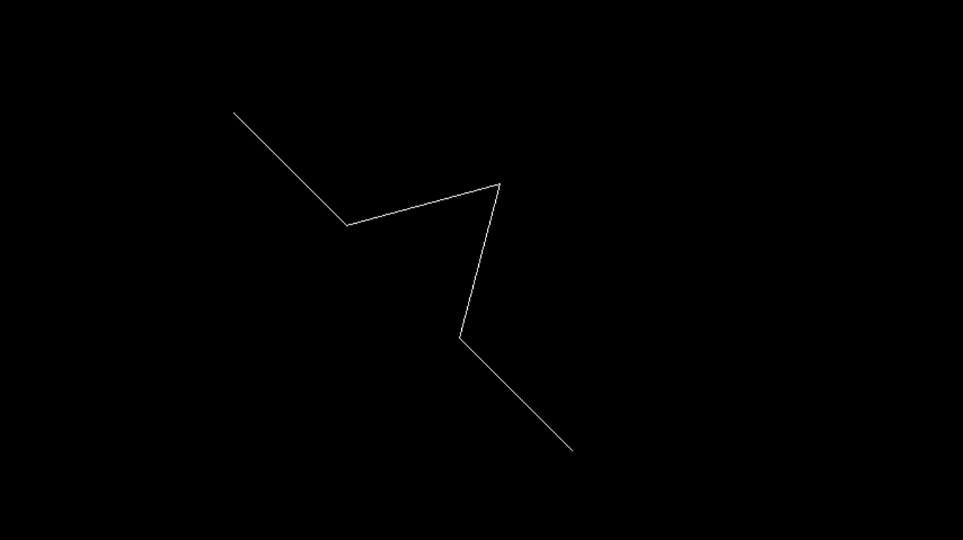

**Conclusion** - Comment on

1. **Difference from Bezier Curve:**The main difference between Bezier curves and the Koch curve is that Bezier curves are smooth, continuous curves used in design and computer graphics, while the Koch curve is a fractal curve characterized by self-similar patterns and recursive subdivision, often used in mathematics and recreational geometry.
2. **Application**:The Koch curve is primarily used in mathematics and recreational geometry to illustrate fractal concepts and explore self-similar, recursive patterns. It's more of a mathematical curiosity and educational tool rather than a practical application in most fields.